THE CATHOLIC UNIVERSITY OF EASTERN AFRICA

**P.O. Box 62157**

**00200 Nairobi - KENYA**

**Telephone: 891601-6**

**Fax: 254-20-891084**

**E-mail:academics@cuea.edu**

**A. M. E. C. E. A**

**DEPARTMENT OF COMPUTER & INFORMATION SCIENCE**

**CMT 314: MOBILE APPLICATIONS DEVELOPMENT**

**Task 3 | Unit Project Design**

**Group Number: __**

**Unit Project Title**

iMarket Grocery Mobile application

**Unit Project Brief Description**

The iMarket Online Grocery Mobile Application is a cutting-edge solution aimed at revolutionizing the way customers shop for groceries thus, make "grocery shopping made-easy" a reality. This mobile app will provide a seamless and convenient shopping experience, allowing users to browse, select, and purchase a wide range of grocery products from the comfort of their smartphones. iMarket is committed to delivering fresh and quality produce, pantry staples like “honey” to customers' doorsteps.

**Unit Project design**

1. Number of Activities---- 11
2. Number of reports---five
3. Products according to categories
4. Cart
5. User information
6. Orders
7. Total product prices
8. Attach Navigation structure (map) complete with database connectivity

**Activities connected to the database:**

Add information

If not registered

Activity 2: sign up

Confirm if infor in database

database

database

Activity 1: log in

Fetch information

database

If non-exists and not status open

Activity 4: create cart

Activity 3: view products

View products

Database

Activity 6: checkout

Store order

Fetch order

If a cart exists, add item to cart.

Activity 5: view cart

Database

DATABASE ENTITY RELATION DIAGRAM

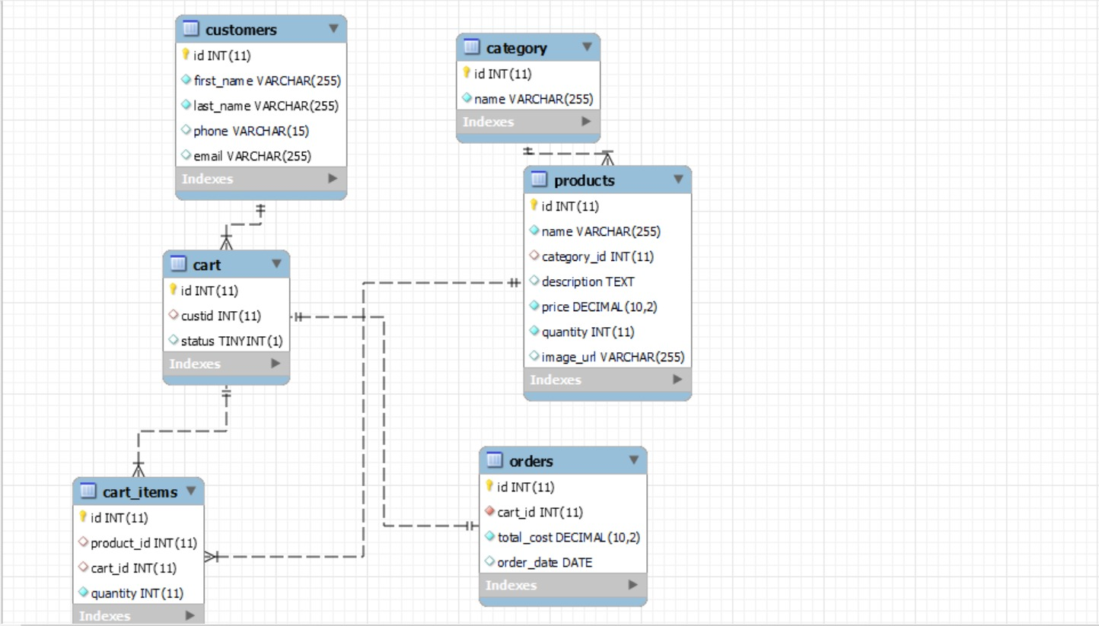

NAVIGATION MAP OF THE APPLICATION

